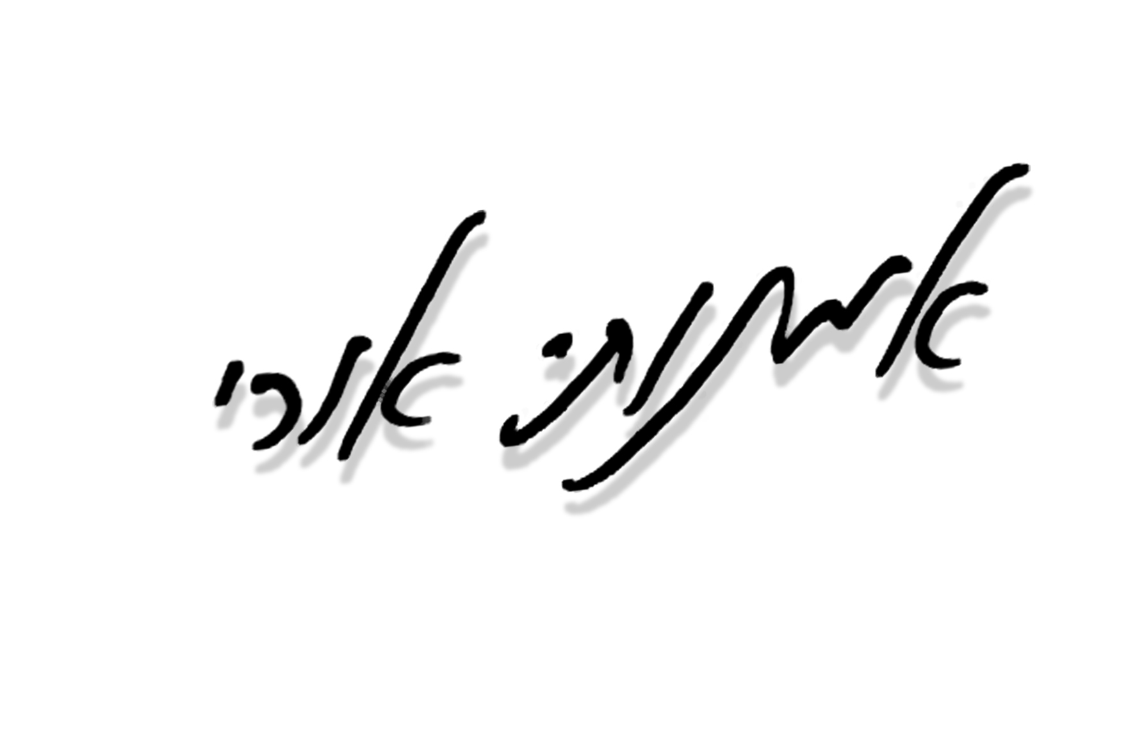
Uri Omanuti

C u r r i c u l u m V i t a e

YITZUG 1 Agency – Tel Aviv, Israel : +972-3-5272748

Directing and play writing Credits

2016 "Mozart's Magic" - Director, At the 26th Children’s Theater Festival in Haifa over the intermediate days of Passover, Mozart’s Magic won Best Play with additional awards going to Shai Lahav for Best Playwright and to Batya and Michael Pik for Best Set.
2015 "Stage Awards" - Director and Writer, Awards for children and youth theatre.
"Goethe institute Theater" - directing and conducting a series of theatrical performances at universities in Israel, in honor of the 50th anniversary of relations between Israel and Germany, on behalf of the "Goethe Institute". German plays pieces in Hebrew and German.
"Singing and remembering" - directoe assistant for the main Israel ceremony on in Jerusalem live, TV International.
2014 Member of the "Israeli stage reward for Children and Youth" 2014.
Meizler Production: “Fredi” musical comedy show. (Director)
Lazer Production: “Lolipop” musical comedy show. (Director)
2013 Mini Israel Production: “The Hidden treasure”. (Director)
Youtheatre Production: "My Best Friend". (Director)
Youtheatre Production.: "Violin Like". (Director)
Yum Production: "singing at the movies" (Musical performance). (Director)
2012 Hifa Theatre: "Amalia's Father Is Going To Australia". (Director)
Shraga Bar & Rachel shein : "KOL-HAKAVOD". (Director)
Vibe Dance Company: "The Hair Show". (Director and script writer)
Mate Omanim: "Around the world in 80 days". (Writer and director)
2011 Gal Production: “Pinocchio”. (Director)
Park Theatre: "Dumbo". (Director)
Zvi-Lahat co.: "Viva Las Vegas". (Director)
2010 Gal Production: “The Cat In Boots”. (Writer and director)
Solan Production: "Doctor Dolittle". (Writer and director)
Youth Theatre production: "When the Shark and the Fish First Met". (Writer and actor)
2C production: "Yaniv's Green Thoughts". (Writer and director)
2009 Srutnick production: "The Sorcerer's Apprentice". (Writer and director)

Theatre Acting Credits

2007 Habima National Theatre: “The Troop”. Role: Doron. Written by: Anat Gov. Director: Ilan Ronen.
2004 Beit - Lessin Theatre: “Piaf”. Role: Waiter / Soldier. Written by: Pam Gems. Director: Leslie Lawton.
2003/4 Beit - Lessin Theatre: “Caught in the Net”. Role: Gavin Smith. Written by: Ray Cooney. Director: Leslie Lawton.
2004 Ha-Kameri Theatre: “Theatre coffee shop”. Poems reading.
2003 Habima National Theatre: “They Shoot Pigeons Too", Role: Daniel Written by: Haim Idisis.. Director: Revital Shkuri.
‏2002 Habima National Theatre: “The Witch” Role:Marcus. Written by: A. Goldfaden. Director: Miki Gorevich.
2002 Nava Productions: “The Yellow Brick Road" (Based on The Wizard of Oz).
Role: Scarecrow. Written and Directed by: Tsvia Huberman.
2001 Habima National Theatre: “Mothers of Plaza De Maio”. Role: Daniel. Writer and Director: Helena Corkin.
2001 “Asi & Guri” - An original comedy show. Improvisation and sketches performance.
2000 Z.O.A. - Fringe Theatre: “Woolen Dog”, Role: Mooshon. Writer and Director: Sinay Roni.
- Abu-Gosh Festival: “Cry, Beloved Country”. Soloist of the Efroni singing group.
- Domino Gros - Performer and Writer for the nonsense improvisation nights.
1993/6 Air Force Theatre Band: Military Service as an Actor.

Television Credits

2007 “Screens” - (YES satellite) TV Daily Drama. Role: Hacker.
Director: Sirkin Dany.
“Smack The Pony – Israeli version” channel 2 –. Comic Presenter.
2005 “Telenovela LTD” Channel 3 – Soap opera. Role: Niv.
“Yellow tabloid” Entertainment Channel – Celebrities TV quiz - Host.
“Kama-Kama” 1st Channel – mathematics' TV game - Host.
“The Strip” Comedy Channel – Impersonations.
2003/4 “Erev Adir” Channel 2 – Comedy program. Comic Presenter (sketches,
Impersonations).
2003 “Smarty” Logi-Channel – General knowledge program. Host.
2003 “The Commercials Special” Channel 10 – Comic Presenter (gags, sketches).
2003 “Comi-Comi” Fox Kids Channel – Gags writer.
2002 “The Revolution Broadcasting” Channel 2 – Sketch writer and performer.
2002 “E-pchi & D-pchi” Channel 2 - Musical children’s program. Role: E-pchi.
Three seasons in a row.
2002 “Two Minutes Away From Fureidis” - Channel 3 – TV Drama. Role: Niv.
Director: Sirkin Dany.
2002 “Un Garcon, Une Fille” - Channel 2 - Special appearance.
2001 “Love at Second Sight” - Feature Film – Role: Student. Director: Bat-Adam Michal.
2000 “Din-Din’s Drum” - TV Drama. Role: Queen's servant. Director: Eitan Fox.
1997 “BAAL BAAL LEV / Got to have a Heart” - TV Drama. Role: Nohav. Director: Eitan Fox.
1997 “Only In Israel” Channel 2 – Variety show, Special appearance.
1996 “Zap la Rishon” - Channel 1 - Gags and sketches writer. Monologue performer.
1990-1988 “Tofsim Rosh”; “Kriat Kivun”; “Eliezer Rock Opera” - Channel 1: Youth TV programs – actor and singer.

Dubbing

2012 "The pirates" – Role: Number two.
2011 "Arthur Christmas" – Role: Arthur.
2008 "Star Wars" – Role: Battle droids.
"Fly me to the moon" – Role: Neil Armstrong.
"Lazy town" – Role: Sportacus.
2007 – 2006 "Surf's Up"- Role: Cody.
"Harry Potter and the Order of the Phoenix".
"The Simpsons Movie".
2005 "Harry Potter and the Goblet of Fire" - Barty Crouch Junior
2003-2008 Radio broadcast and TV Cartoons.

Education

2000 - 1996 “Nissan Nativ” Acting Studio, Tel Aviv – Graduate.
1993 - 1990 “Thelma Yellin” High School of the Arts, Graduate. Majored in drama.
1990 - 1988 “School of Arts” - Graduate. Majored in drama.

Miscellaneous

- Awarded the “Sharet Fund” Scholarship (1998).
- “Nissan Alternative” - Promoter and Creator of the project. Stage for original performances, Sponsored by “Nissan Nativ” Acting Studio.
- Magician. Balloons sculptor.
- TV commercials: Juicy fruit – chewing gum, Bamba – food product, Ha-Ir Newspaper – Event's Magazine, Bezeq - The Israel Telecommunications Corporation, Pinuk - Shower Products, Cellcom – Cellular Company, Hapoalim Bank– Israel's leading bank, Isracard - Credit card company, Tirat Tzvi - Food Company.

